**Performance test for DeviceType**

**Test Summary:**

|  |  |
| --- | --- |
| Kernel Request | DeviceType- Service to save Device Type |
| Base URL | https://integ.mosip.io |
| Execution Window | 2018/12/21 03:37 PM IST to 2018/12/21 04:07 PM IST |
| Maximum User Load | 100 |
| Tool Used | Jmeter |
| Average Response Time | 398 |
| Throughput Achieved | 27.88 |

Transaction Summary:

|  |  |  |  |  |  |  |  |
| --- | --- | --- | --- | --- | --- | --- | --- |
| Label | #Sample | Average | 90% line(ms) | Min(ms) | Max(ms) | Error% | Throughput/Sec |
| Service to save Device Type | 62256 | 398 | 376 | 62 | 42012 | 0.01% | 27.88 |

Response Times Over Time

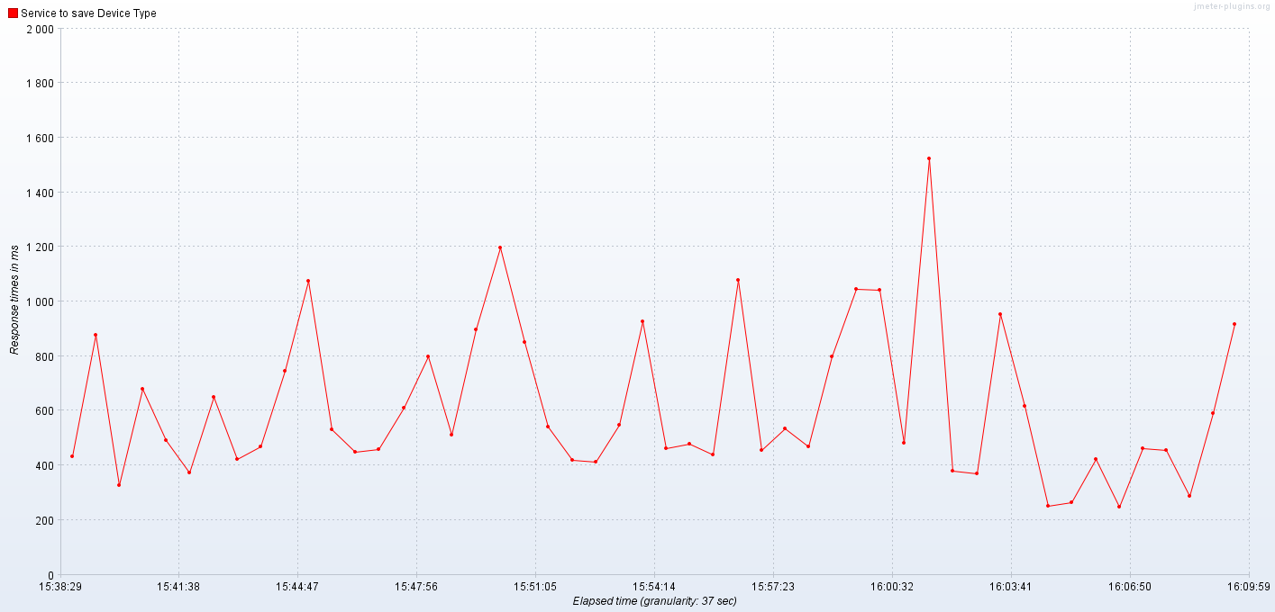

Bytes Throughput Over Time (bytes/sec)

